Data Visualization with Google Sheets and Maps

In lesson 6.4 Big Data, we investigated large data sets and how to process them. In this lesson, we will create our own data visualizations using charts in Google Spreadsheets and map visualizations using Google Maps.

# Activity 1: Explore Data Visualizations

Working with a partner, explore the following visualization from [census.gov](https://www.census.gov/dataviz/visualizations/health_insurance/) (or another visualization that your teacher suggests) and answer the following questions.



1. What is the data shown in this visualization?
2. What type of data is used — text, numbers, geocodes, date and time, etc.?
3. What conclusions can you draw from the data?
4. How is the data presented in the visualization that makes it easy to understand and use?
5. What are the drawbacks of this visualization?

Watch and discuss the TED-Ed video below on how data can also be manipulated in data visualizations: <https://www.youtube.com/watch?v=E91bGT9BjYk>

# Activity 2: Google Sheets

A spreadsheet is a document where the data is arranged in rows and columns. Spreadsheets allow formulas to be used to make calculations from the data and have charting capabilities. We will be using Google Sheets in Google Drive as our spreadsheet software.

1. Open the [Astraptes Butterflies data set](https://docs.google.com/spreadsheets/d/12fRy-mhBAhj-6GlHi9y-5tKlkBo7OeSgcWzAKgIXQ30/edit?usp=sharing) in Google Drive.
2. Pull down the **File** menu at the top and select **Make a Copy.** This will save a copy of the spreadsheet in your Google Drive and you will be able to edit it.
3. This data set shows butterfly specimens captured and tagged in the Guanacaste National Park in Costa Rica. Look through the data and notice that the first column (herbivore species) is the species of each butterfly that was tagged. The last columns show the latitude and longitude that the where the butterfly was tagged.
4. **Formulas and Functions:** Each box in the spreadsheet is called a **cell**. Every cell in the spreadsheet is identifiable by its column letter and row number. For example, cell **A2** refers to the box at column A and row 2 below and contains the data *Astraptes SENNOV* which is a butterfly species.

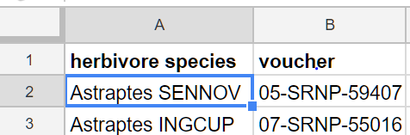

We can manipulate numeric data in a spreadsheet by using **formulas** and **functions** built into the spreadsheet software. Typing in a **=** in a cell signals the start of a formula like **=K2 + K3** or a function like **=SUM(K2,K3)**. These functions can take a list of cells or a range of cells such as **K2:K4** which is equivalent to the list **K2, K3, K4**. There are many built-in functions in standard spreadsheet software, but the most commonly used ones are SUM, AVERAGE, COUNT, MAX, and MIN. Here is a [tutorial](https://www.gcflearnfree.org/googlespreadsheets/working-with-functions/1/) that reviews how to use functions in Google Sheets.

Let’s use a formula to calculate the average wingspan of the butterflies in our spreadsheet. Column **K** contains the wingspan measurement of each butterfly.

* Scroll down to the empty cell K89 (column K, row 89).
* Type in the formula **=AVERAGE(K2:K88)** like below. This will average the data in column K rows 2-88. You could select the data that you want instead of typing in the cell numbers. When you hit enter, it will compute the average 54.63 (you can control the precision with the precision buttons at the top).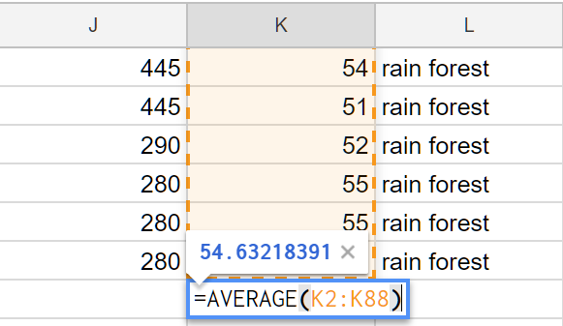
* **(Reflection)** Write another formula that calculates the average **elevation** for this data. Write your formula and the result found in your portfolio.

1. **Charts:** Let’s make a chart to visualize some of the data in this spreadsheet.
   1. Click on the **A** heading in the first column (herbivore species).
   2. From the **Insert** menu at the top, select **Chart.**
   3. You will see a bar chart of the different species found in column A. Investigate the many chart options available. Try a pie chart like below. Here’s [more information about different charts](https://support.google.com/docs/answer/190718) in Google Sheets.

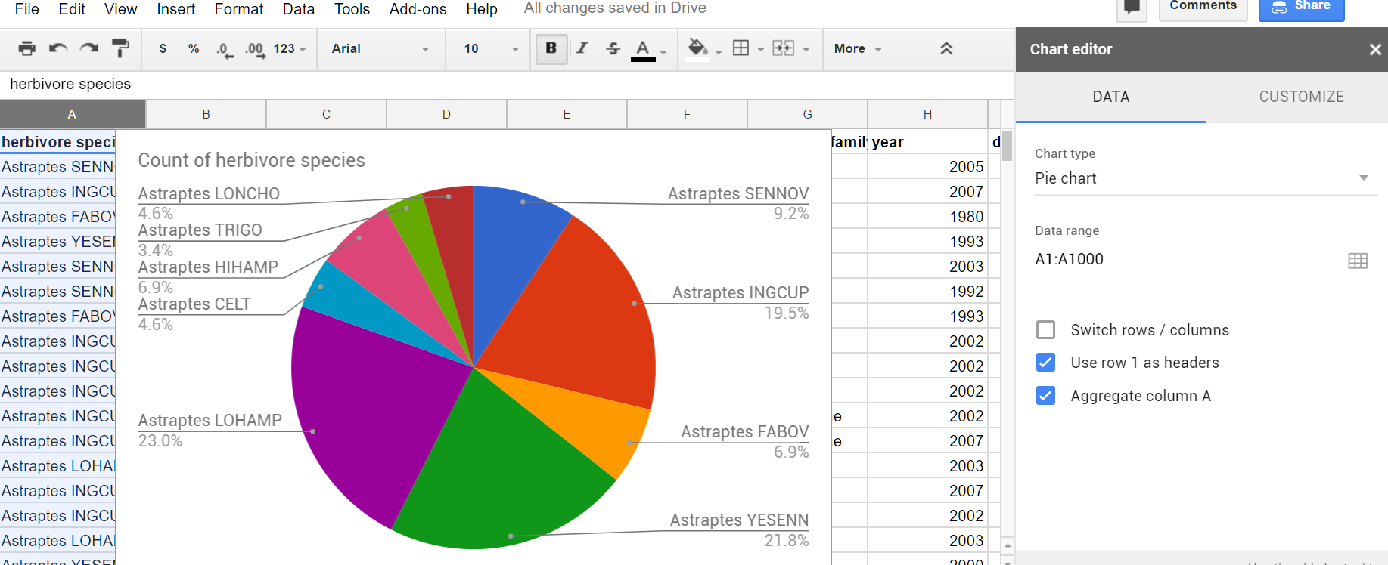

d. The chart can help us answer questions such as which species is the most common?

e. Once you are finished designing your chart, you can click on the dots in the top right corner of the chart to copy the image or move it to its own sheet.

1. Make more charts to answer the following questions:
   1. (**Reflection**) Are there more male or female butterflies in this data set? Include a screenshot of your chart in your portfolio to answer this question. What kind of data is in your chart?
   2. (**Reflection)** Which ecological environment (primary eco column) do these butterflies like to live in? There is no clear winner in this question so give the percentages in each ecological environment in a screenshot of your chart and describe the data in your portfolio.
   3. (**Reflection**) Come up with a 3rd question and use charting to answer it. Include a screenshot of your chart in your portfolio to answer this question. What kind of data is in your chart?

Activity 3: Google Maps

The last columns in the spreadsheet contain location data -- latitudes and longitude in which the butterflies were found. We can map this data using Google Maps. For troubleshooting in this activity, refer to the [Google My Maps Help Center](https://support.google.com/mymaps/#topic=3188329).

1. Go to <http://www.google.com/mymaps> and click on the **Create A New Map** button. The created map will be saved in your Google Drive.
2. Change the *Untitled Map* heading to a title like *Butterflies Map* and click on the blue **Import** button as seen below:

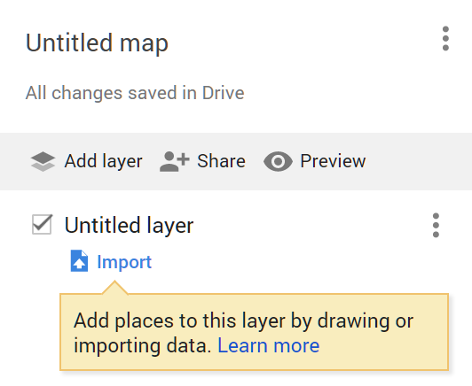

1. Click on **Google Drive** as seen below and find your spreadsheet.

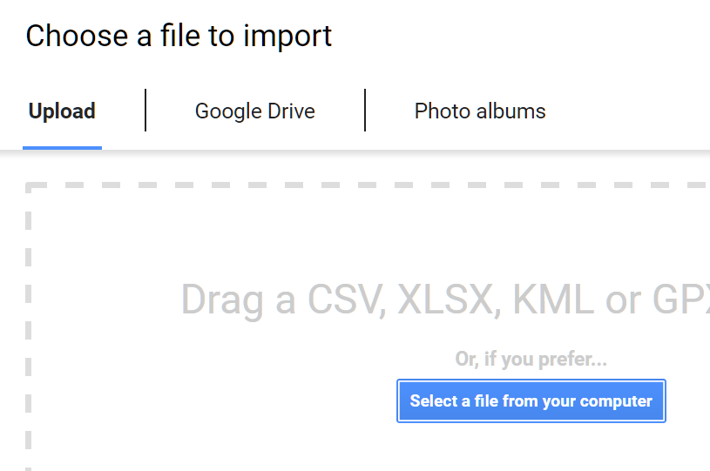

1. Scroll down to select the **Latitude** and **Longitude** columns as seen below.

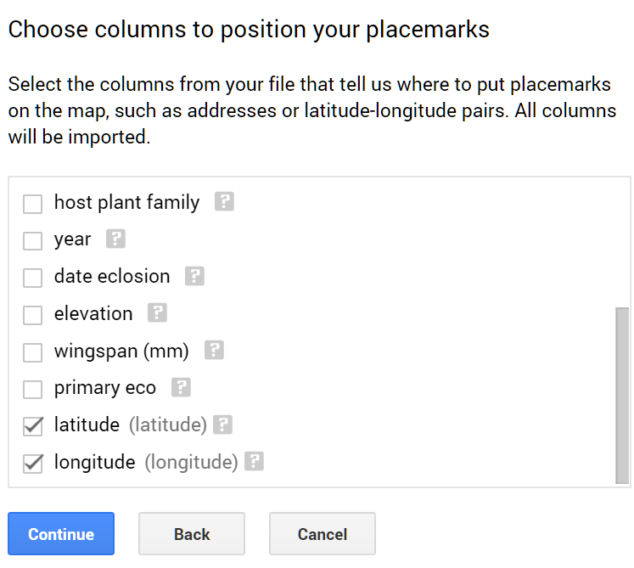

1. Pick the **herbivore species** column as the title for the placemarks.
2. Google maps will place your data set as markers on the map. Click on some of the markers to see your data. You can style the markers to be different colors and have labels. Click on the paint roller icon like below to group places by herbivore species or by another column like primary eco and add labels from one of the columns, and click on the paintcan to choose different icons.

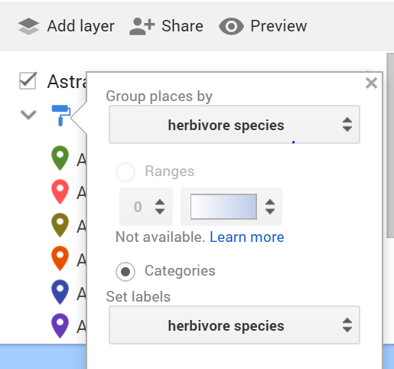

1. Click on Share to share your map with your teacher or to change the settings to anyone with the link can view.
2. **(Reflection)** Copy the link to your portfolio. Click on Preview and grab a screenshot of your map for your portfolio.

***Nice work! Complete the Self-Check Exercises and Portfolio Reflection Questions as directed by your instructor.***